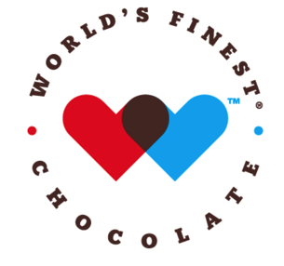
DEAR PARENTS,
We are excited to announce an upcoming fundraiser featuring…

We are having fundraiser to help support our program. We appreciate everyone getting involved. THANK YOU!

- Each bar costs $1.00 collect $60 per box sold
- Each variety box contains:
3 EASY STEPS
12 almond bars
- Complete Permission Form
- Sell 60 bars
- Return $60

12 caramel bars
12 crisp bars
12 wafer bars
6 milk chocolate bars
6 dark chocolate bars

up to 45% PROFIT for our program

Sale Ends in 2 weeks
---------------------------------------------------------------------------------------
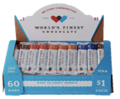
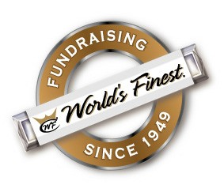
______
Permission
Slip

______________

____________________

_____________________
_____________________
I understand I will be responsible for turning in $60 per box checked out —chocolate may not be returned.
Grade
Phone #
Teacher
Parent Signature

Student Name
I understand I will be responsible for turning in $60 per box checked out.
Chocolate may not be returned.
Yes, I want to check out 1 box of chocolate.

