

YOUR SCHOOL/GRADE/CLUB

WORLDS FINEST CHOCOLATE BAR FUNDAISER TO SUPPORT YOUR STUDENTS TRIP TO

DESTINATON/EVENT

Dear Parents:

This year’s XX Grade field trip is to XXXX from XXXX thru XXXX.

We are pleased to offer a terrific fundraising opportunity to help support your students trip cost of $XXX.

A great fundraiser, the World’s Finest Chocolate Bars $1 Bars!!

* **ALL PROFITS RAISED GOES DIRECTLY TOWARDS YOUR STUDENTS ACCOUNT -- $25 PER BOX!**
* Each bar costs **$1.00**
* Each variety box contains: 12 almond, 12caramel, 12 crisp, 12 milk choc, 6 dark chocolate & 12 wafer

**100% OF PROFITS RASIED GO DIRECTLY TOWARD YOUR STUDENT ACCOUNT -- $25 PER BX**

1. Complete Permission Form
2. Sell 60 bars
3. Return $60 and your account is credited $25

*\*earn $25 credit for each box sold!*

**THEN…. CHECK-OUT ANOTHER BOX!**

**3 EASY STEPS**

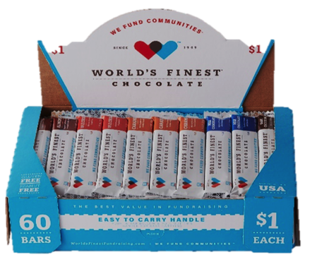

Permission   
Slip



Grade

Teacher

Signature

Student Name

Yes, I want to check out 1 box of chocolate.

*I understand I am responsible for turning in $60 in ONE WEEK and that chocolate may NOT be returned

Phone #